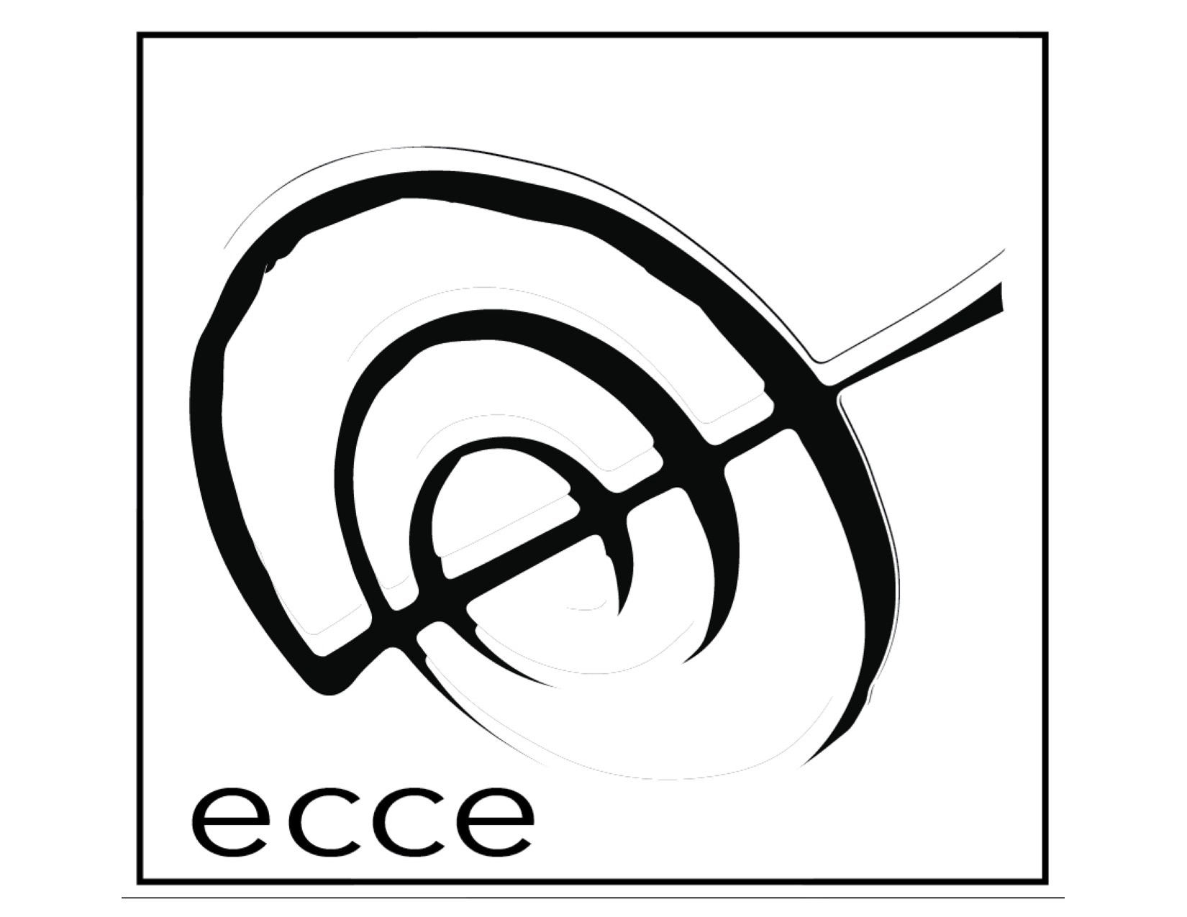

Etchings 2023 Application Form:

In one email, please send us the following:

- Two scores representing your best work for any instrumentation (PDF)

- Recordings of these works (optional) (MP3)

- In lieu of uploading scores and/or MP3s along with your application, you may provide links to your scores and recordings but these links must remain active until May 2nd. Please no links to downloads.

- One or two works to be considered for performance during the festival (one will be chosen) for any combination of the following instrumentation:
Flute (alto/picc), oboe, clarinet (bass clarinet), violin, viola,
cello, horn, trumpet, harp, piano).

- Short bio or a CV.

- Completed Application Form (below)

- Email to: eccemailbox@gmail.com. Subject line: Etchings 2023 Application.

- Complete the Paypal application fee ($25)

Application form

Last Name:___________________________

First Name: _______________________________

Date of Birth (MM/DD/YYYY): _____/______/________

Permanent Street Address (where you can be reached): ________________________

City/Town:___________________ State/Province:____________

Country:__________________________ Postal Code: __________

Telephone number: _________________________

E-mail Address (please print clearly): ___________________________

How did you hear about us? ______________________________________

Education: List all undergraduate and graduate degrees (include any programs in which you are currently enrolled). List degree, institution and date received.

_______________________________________________________________________

List any special or significant achievements you would like to share (optional)

_______________________________________________________________________

_______________________________________________________________________

Please list the scores and/or recordings you are submitting in your application:

_______________________________________________________________________

_______________________________________________________________________

_______________________________________________________________________

Briefly describe any unique talents or curiosities you have that you would contribute to the community?
_______________________________________________________________________

_______________________________________________________________________

_______________________________________________________________________

Why do you think a fellowship opportunity at Etchings will help your artistry?

_______________________________________________________________________

_______________________________________________________________________

_______________________________________________________________________

Briefly describe a few things that inspire your compositional process.

_______________________________________________________________________

_______________________________________________________________________
How do you conceive of interactions with performers as instructive toward your compositional process?

_______________________________________________________________________

_______________________________________________________________________

_______________________________________________________________________

Signature:_________________________________________________Date:__________

